NAME : AGULLA AISHWARYA
ENROLLMENT NO : 2403A54128
BATCH N0 : 04
ASSIGNMENT : 1.4

**Task Description #2

* A function in Python that returns the maximum of three numbers using GitHub Copilot. Use
an appropriate comment as a prompt.
*Expected Output #2
• Python function that takes three inputs and returns the largest value. Include the code and
output.
PROMPT:
Write a python function that returns the maximum of three numbers.

CODE:

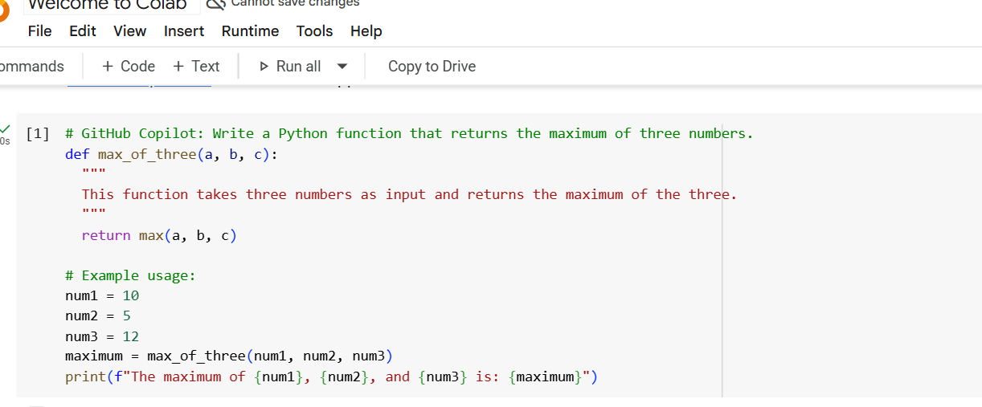
Output:

EXPLANATION :
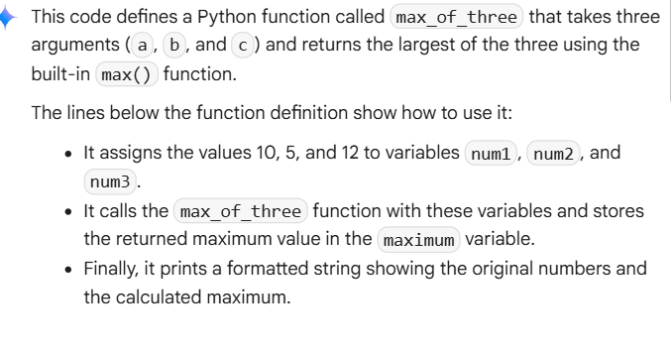
**Task Description #3
• Use GitHub Copilot to create a recursive Python function that calculates the factorial of a
number.
*PROMPT
Write a recursive Python function that calculates the factorial of a number.
Expected Output #3
• Python function for factorial using recursion with input and output examples.

CODE:
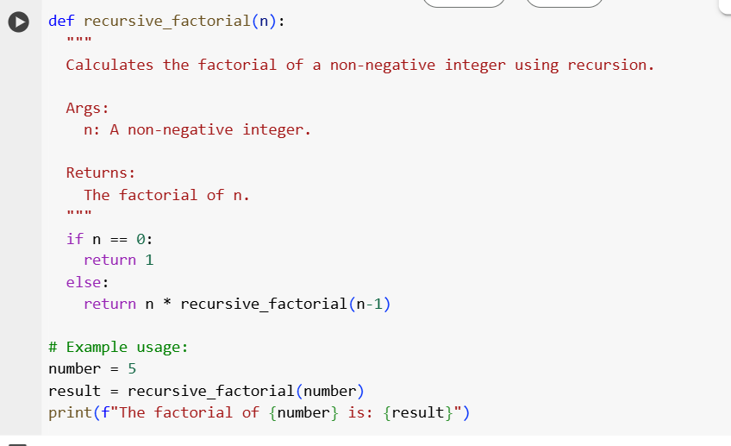

Output:
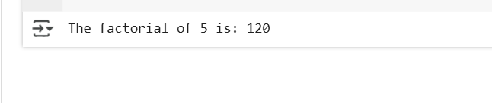
EXPLANATION :
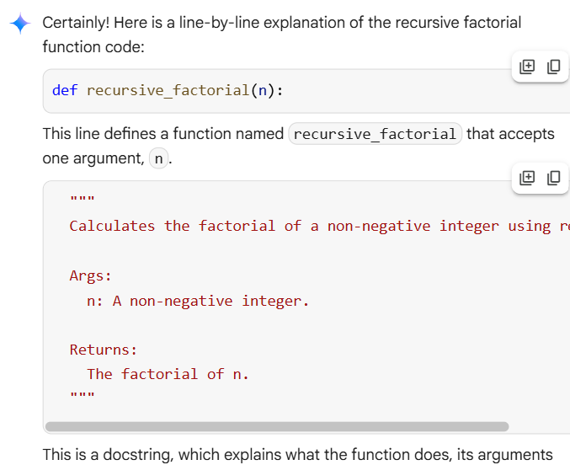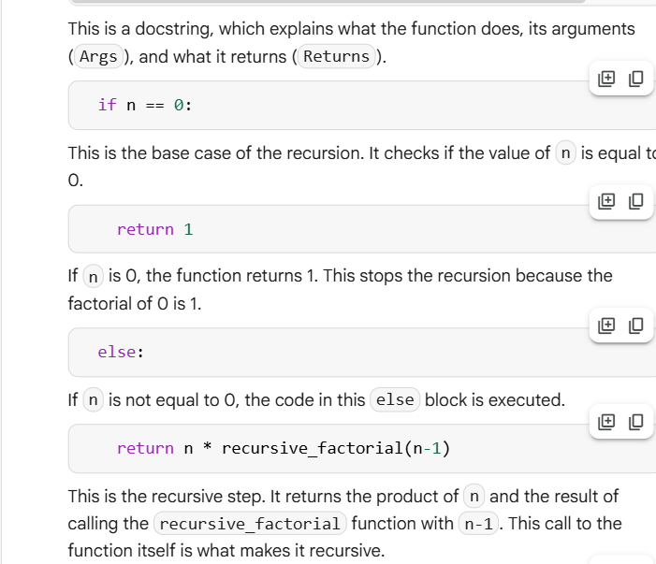
**Task Description #4
• Prompt GitHub Copilot to create a class named Student with attributes name, roll_no, and
marks. Add a method to display student details
.
*Expected Output #4
• Python class definition with an initializer and a display method. Include object creation and
output
*PROMPT:
Write a python programme to ask student name with attributes name ,rollno, and marks .

CODE:
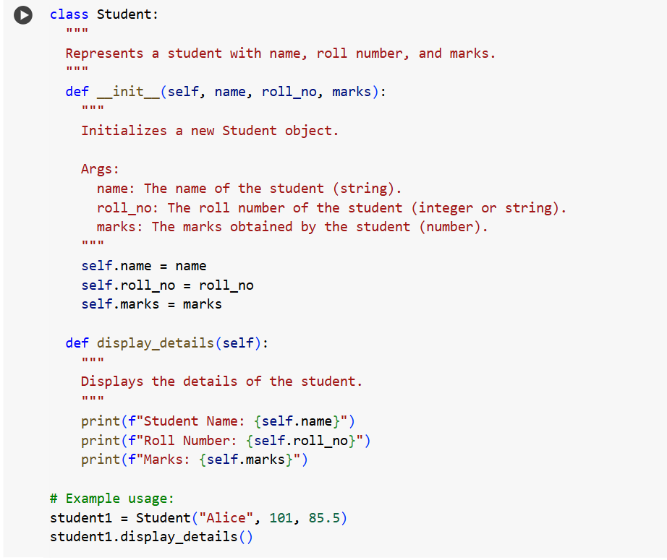
OUTPUT:
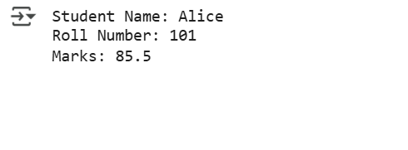
EXPLANATION:
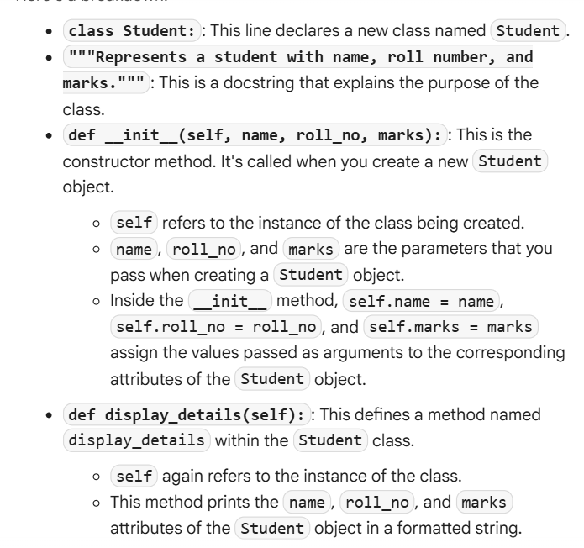
**Task Description #5
• Ask GitHub Copilot to generate a Python function that takes a string as input and returns the
frequency of each word.
Expected Output #5 :
• Python function that returns word frequency using a dictionary. Provide sample input and
output.
*PROMPT :
Write a python programme to ask a python function to takes string as a input and returns that frequency of every word.

CODE:
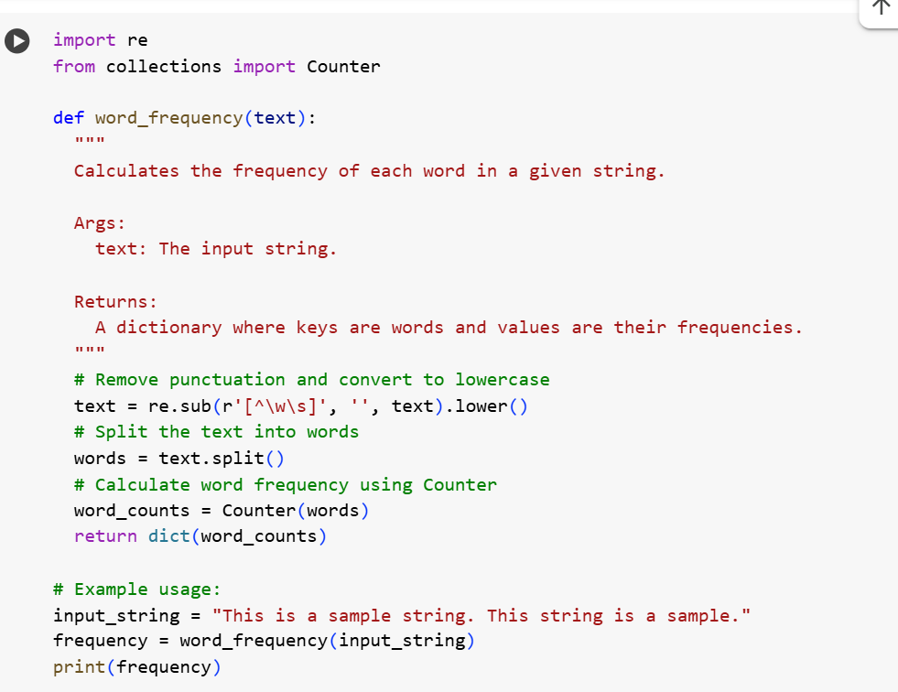
OUTPUT :
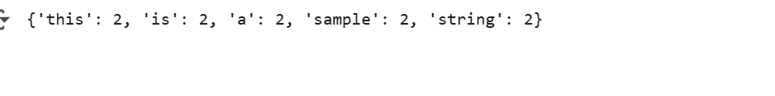
EXPLANATION:
